**IMPLEMENTING CROSS ORIGIN RESOURCE SHARING**

IN ORDER TO ACHIEVE CORS, IN THIS CASE WITH AJAX JAVASCRIPT REQUESTS, WE HAVE TO INSTALL AND CONFIGURE A COUPLE OF TOOLS WHICH WILL ALLLOW US TO IMPLEMENT CORS WITH ANY PROBLE. HOWEVER IT’S NECCESSARY TO TAKE CARE WITH INFORMATION POSTED HERE:

<http://www.django-rest-framework.org/topics/ajax-csrf-cors/>

ONCE WE’VE ACCEDED TO OUR VAGRANT SERVER AND ACTIVATED OUR VIRTUAL ENVIRONMENT, WE MUST INSTALL ***django-cors-headers*** PACKAGE WITH ***pip install*** COMMAND:

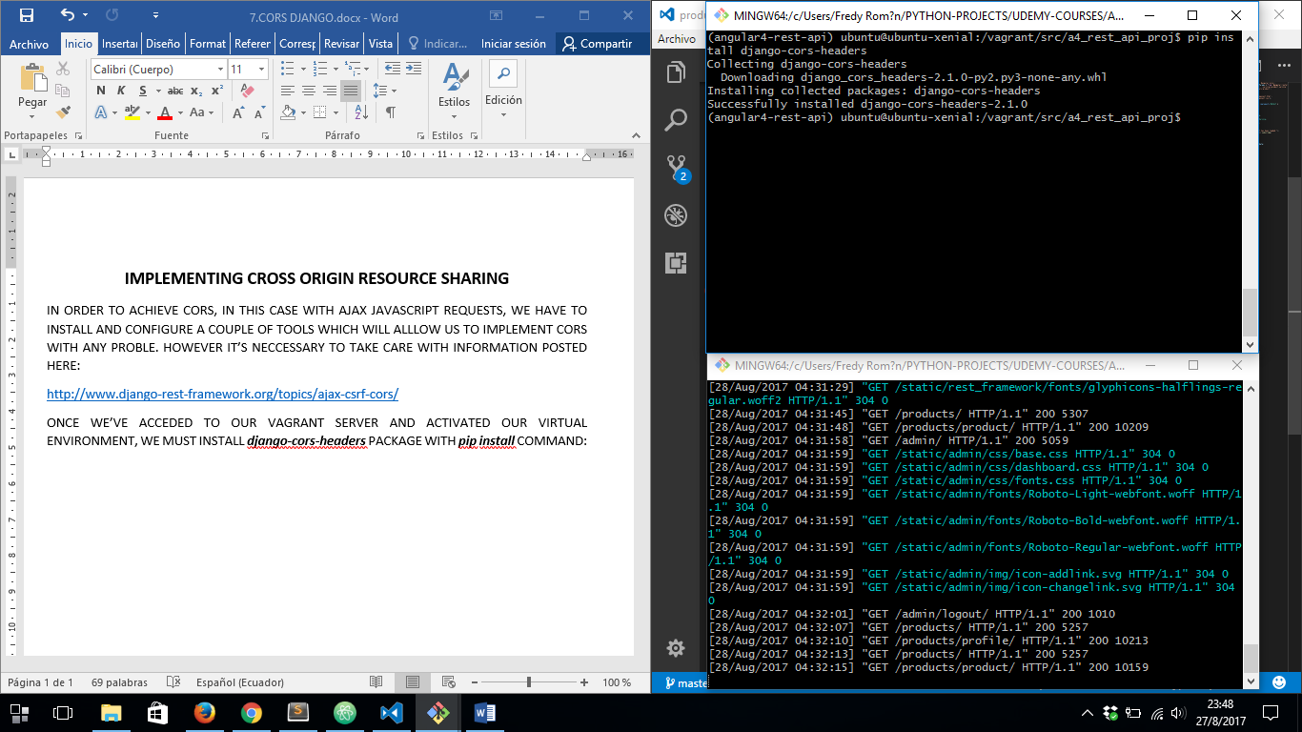

AFTER THAT WE MUST ADD IN ***settings.py*** FILE ON ***INSTALLED_APPS*** ARRAY THE CORS HEADERS JUST INSTALLED:

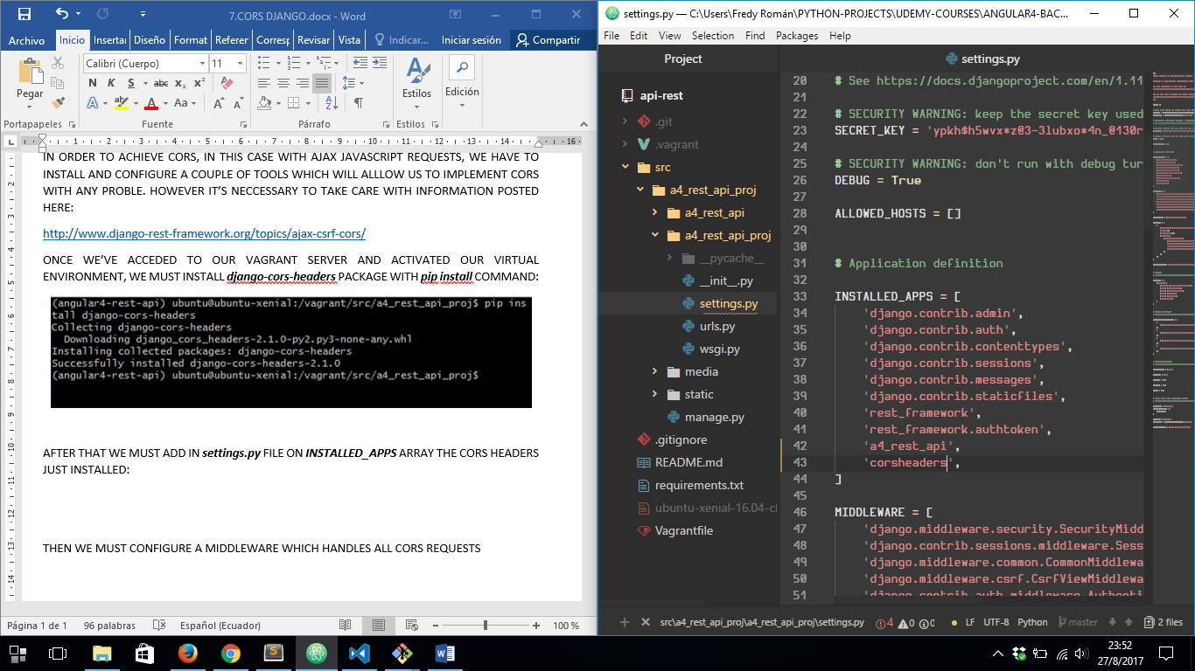

THEN WE MUST CONFIGURE A MIDDLEWARE IN ***settings.py*** FILE, WHICH HANDLES ALL CORS REQUESTS:

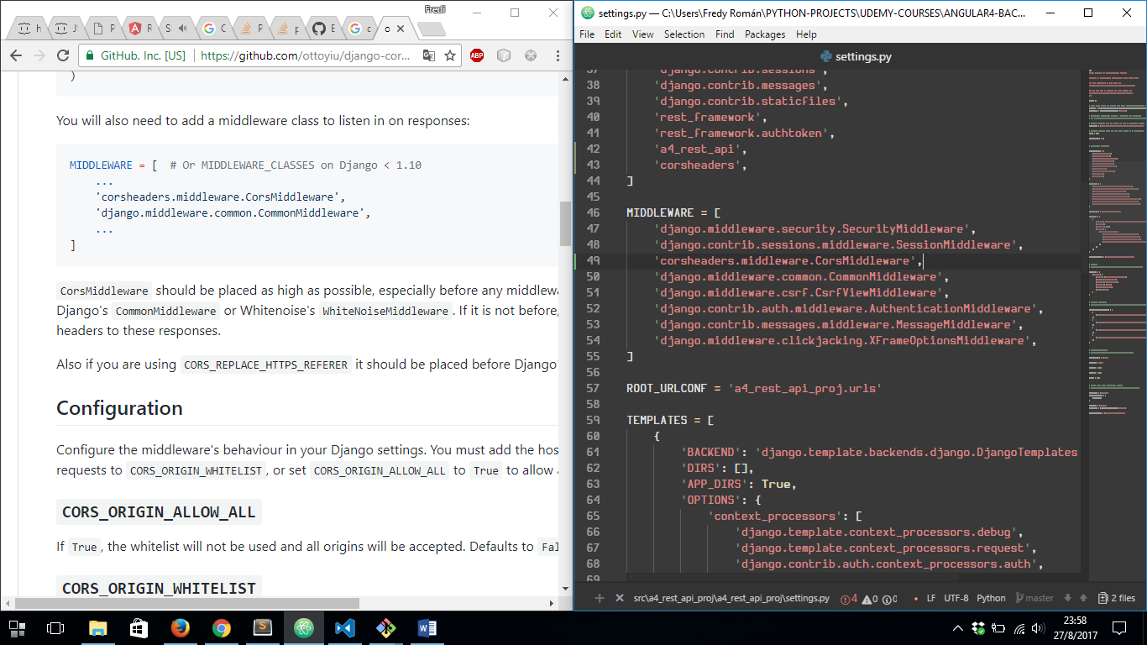

BOTH LINES MUST BE PLACED IN THE WAY IS SHOWN ABOVE.

TAKE CARE ABOUT THIS:

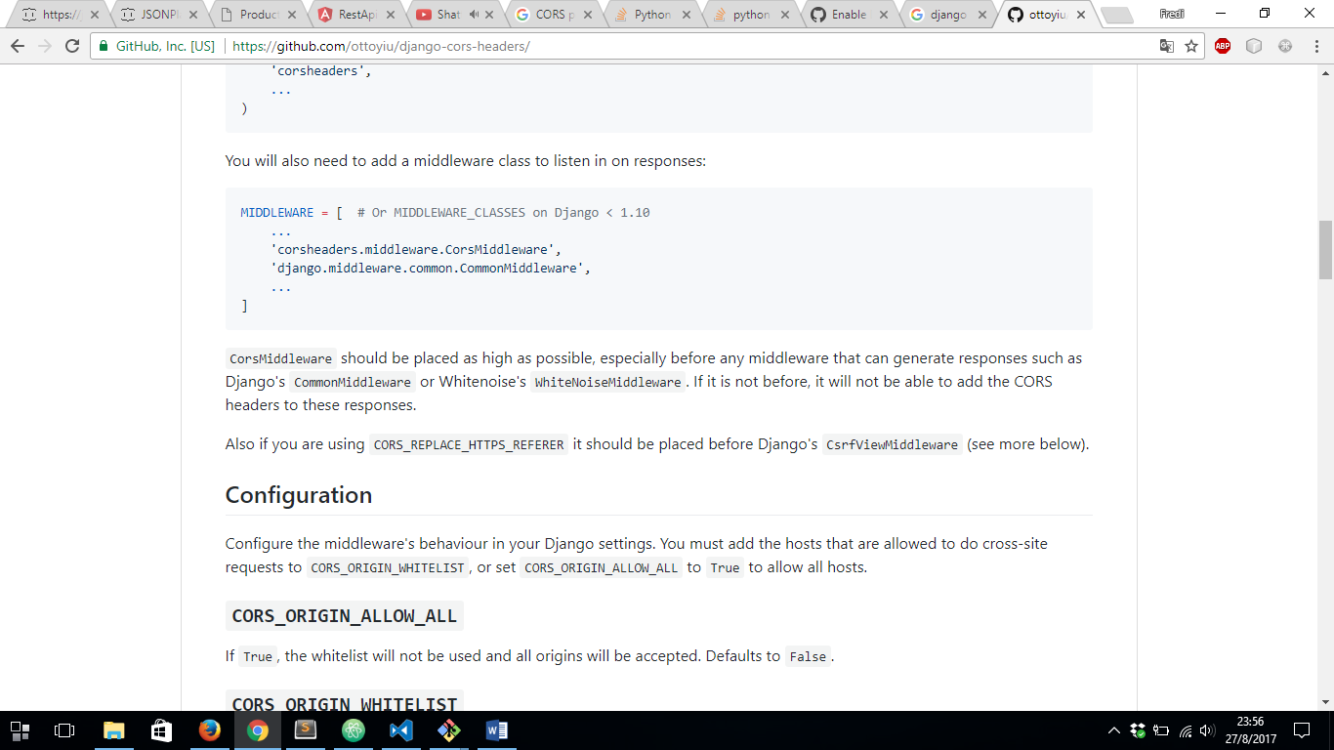

REF: <https://github.com/ottoyiu/django-cors-headers/> (FOLLOW INSTRUCTIONS SETED IN THAT LINK)

VIDEO REF: <https://youtu.be/LQTMY5yVeM4?t=1802>

NEXT WE HAVE TO DO IS ADD NEXT LINES AT THE END OF ***settings.py*** FILE:

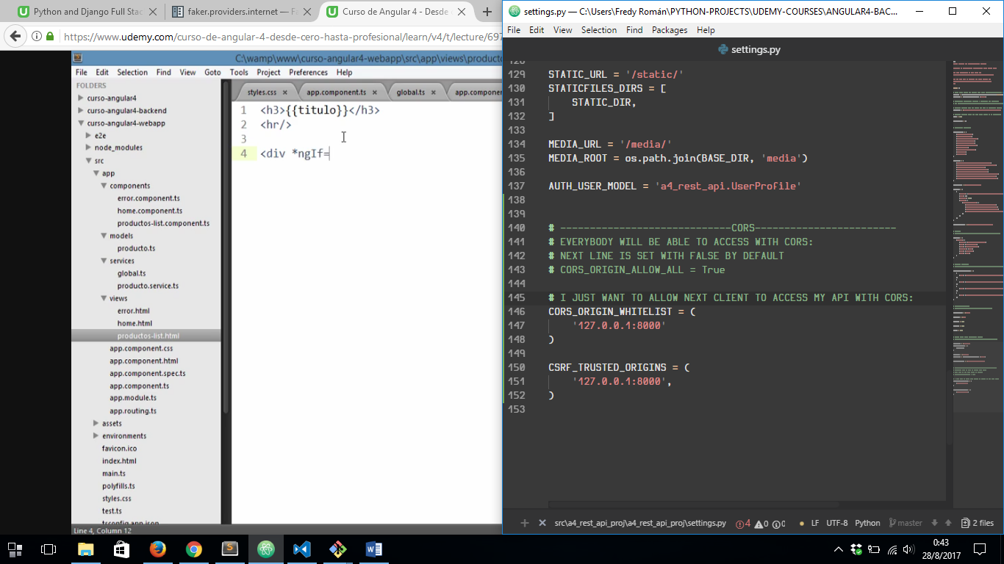

AND THAT’S ALL, NOW WE’RE ABLE TO ACCESS WITH CORS FROM ANGULAR 4 TO A REST API DEVELOPED IN PYTHON